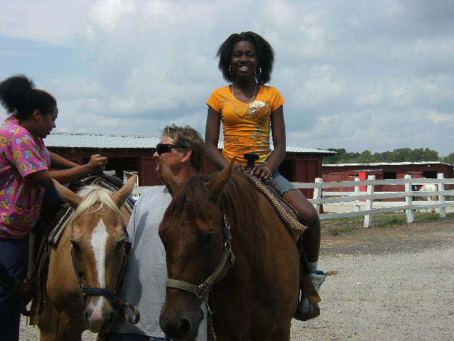
Summer Camp Registration Application Agreement

My World of Smiling Faces Childcare Program
4516 Maple rd., Morningside
Suitland, Maryland. 20746
301-806-3500

Date:
 | Client Name:_______________  Client Address:______________  ________________________  Client Phone:_______________ ________________________ | Child(ren)s Name & Age(s):_____________________________________  Special Needs:____________________________  Week(s) Desired:__________________________  Hours Needed:____________________________  Allergies:______________________________
Summer Break
Field Trips and Activities are listed. Field trips and activities are subject to change.
Every morning enrichment lessons will be introduced, taught and mastered. Monday and Wednesday=Math. Tuesday and Thursday=Language Arts. Friday=Science. Every afternoon social activities and trips will be scheduled. Mondays=Swimming, Tuesdays= Bowling and Go Carts, Wednesday Monuments or Museums and Movies, Friday=field trips, Thursday= crafting, cooking and local parks.
One week of overnight camp will be announced at the end of the school year.

- Week 1: Swimming, Bowling, Movies, Cooking, and Summer Scrap Book

- Week 2: (Short Week) Swimming, National Art Muesum, Sundial and Bird house

- Week 3: Swimming, Bowling, Movies, Cooking, and Watkins Park

- Week 4: Swimming, Go Cart Racing, Zoo, and Kites,

- Week 5: Beach, Chuck-E-Cheese, Cosca Park, Mini Garden

- Week 6: Swimming, Bowling, Jefferson Memorial, 3-D Fish

- Week 7: Swimming, Go Carts, Movies, Watkins Park, Picture Frames

- Week 8: Beach, Bowling , Movies, horseback riding, Clay candy dishes

- Six Flags, Air and Space Museum, 3-D Planets
For the Amount of $250.00 dollars per week for children 3 and up. $200.00 for children under 3 (All Trips, Breakfast, Lunch and Snacks included) Week(s) needed:_______/_______

Client Signature _________________ Provider Signature________________License #16-138356

Client Signature _________________ Witness Print/Signature_________________

