Summer Camp 2023
$7.00 gas weekly fee

MONTHS of JUNE/JULY total months cost- $357.00
Sunday | Monday | Tuesday | Wednesday | Thursday | Friday | Saturday
18  $70  for this weeks field trips | 19  AM: Museum  PM: Arts/Crafts  &Science | 20  Bowling  $10.00 | 21  Splash park  $8.00 | 22  Cooking Class:  Horseback Riding $45.00 | 23  Field Day:  All sports & Relays | 24
25  $61  for this weeks field trips | 26  Pump it up  $15.00 | 27  Movies:  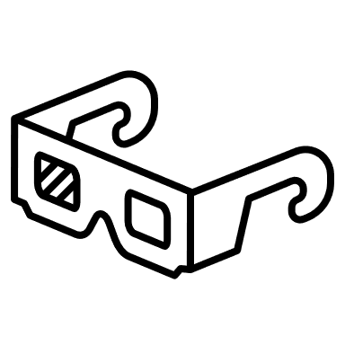  $12.00 | 28  North Beach  $17.00 | 29  ZOO : DC  $10.00 | 30  Field Day:  All sports & Relays | 1
2  $17  for this weeks field trips | 3  AM: Museum  PM: Arts/Crafts  &Science | 4  CLOSED  HAPPY 4TH!!! | 5  Swimming  $10.00 | 6  Cooking Class:  Hiking | 7  Field Day:  All sports & Relays | 8
9  $74  for this weeks field trips | 10  AM: Museum  PM: Arts/Crafts  &Science | 11  Go Cart  $14.00 | 12  Splash park  $8.00 | 13  Cooking Class:  Horseback Riding $45.00 | 14  Field Day:  All sports & Relays | 15
16  $91  for this weeks field trips | 17  Bowling  $12.00 | 18  North Beach  $17.00 | 19 Game Day  AM: Women’s Basketball Game WNBA 25.00  PM: Baseball MLB 15.00 | 20  Pump it up  $15.00 | 21  Field Day:  All sports & Relays | 22
23/30  $44  for this weeks field trips | 24/31  AM: Museum  PM: Arts/Crafts  &Science | 25  Go Cart  $14.00 | 26  Swimming  $10.00 | 27  Cooking Class:  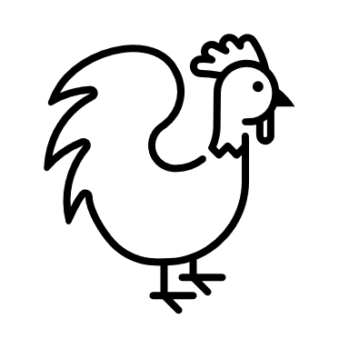  Petting Zoo  $13.00 | 28  Field Day:  All sports & Relays | 29

