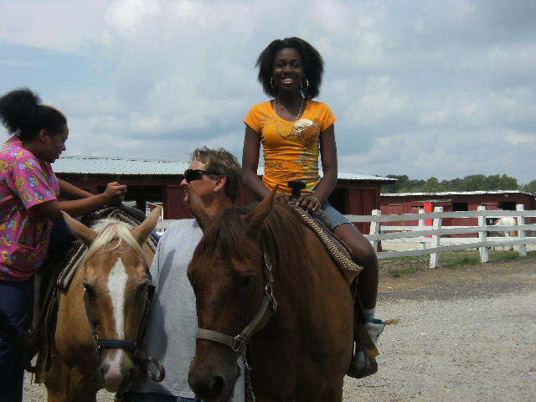
Summer Camp Registration Application Agreement

My World of Smiling Faces Childcare Program
4516 Maple rd., Morningside
Suitland, Maryland. 20746
301-806-3500

Client Name:  _________________________  Client Address:  _________________________  Client Phone:  _________________________ |  | Child(ren)s Name & Age(s):_________________________________  Special Needs:____________________________  Week(s) Desired:__________________________  Hours Needed:____________________________  Allergies:______________________________
 | Summer Break
Field Trips and Activities are listed. Field trips and activities are subject to change.
Every morning enrichment lessons will be introduced, taught and mastered. Monday and Wednesday=Math. Tuesday and Thursday=Language Arts. Friday=Science. Every afternoon social activities and trips will be scheduled. Mondays=Swimming, Tuesdays= Library, Bowling and Go Carts, Wednesday Monuments or Museums and Movies, Friday=field trips, Thursday= Library, crafting, cooking and local parks.
One week of overnight camp will be announced at the end of the school year.

- Week 1: Swimming, Bowling, Movies, Cooking, and Summer Scrap Book

- Week 2: (Short Week) Beach, National Art Muesum, Sundial and Bird house

- Week 3: Swimming, Bowling, Movies, Cooking, and Watkins Park

- Week 4: Swimming, Bounce About, Zoo, and Kites,

- Week 5: Swimming, Bowling, Chuck-E-Cheese, Cosca Park, Mini Garden

- Week 6: Swimming, Go Carts, Jefferson Memorial, 3-D Fish

- Week 7: Beach, Movies, Watkins Park, Picture Frames

- Week 8: Swimming, Go Carts, Movies, Watkins Park, Clay candy dishes

- Week 9: Swimming, Bowling, Lincoln Memorial, Cosca Park, Mini Pillows

- Week 10: Swimming, Go Carts, Bowling, Watkins Park, Floor Mats

- Week 11: Beach, Bowling, Go Carts, Movies, horseback riding, Chuck E Cheese,
 | For the Amount per week of $85 .00 dollars for children 5 yrs. old and up. $100.00 for children 4 yrs. Old. $150.00 for children 3 yrs. Old. (All Breakfast, Lunch and Snacks included) Week(s) needed:_______/_______

Date:

Client Signature ____________________ Provider Signature________________License #16-13835

