
All field trips START at 9:00 AM SHARP. ANY/ALL Arrivals between 8:30am-9:00am WILL MISS BREAKFAST & BATHROOM USE! Please take care of this before late arrivals. NO ARRIVALS AFTER 9:00AM! We will return by 4:00PM. Early pick-ups MUST BE SCHEDULED, and early dismissals will result in missed field tips. All Dates in Yellow are for 3yrs and up. Dates without color are for the 5yrs and up. Under 3yrs will have supervised activities at the facility. Payments are due FRIDAY BEFORE TRIP WEEK.
Summer Camp 2025
$7.00 gas weekly fee

MONTHS of JUNE/JULY Total Cost: $266.00
Sunday | Monday | Tuesday | Wednesday | Thursday | Friday | Saturday
15  Week #1  this weeks field trips | 16  LAST | 17  WEEK | 18  OF | 19    SCHOOL  SUMMER RULES!!! | 20  Field Day:    Family Kickball Day!!! | 21
22  Week #2  this weeks field trips $57.00 | 23  Pump it up    $15.00 | 24  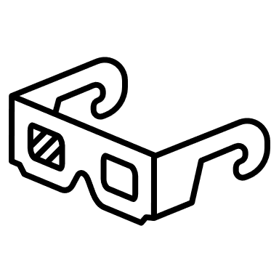  Movies: FREE | 25    Swimming $10.00 | 26  Cooking Class:    Horseback Riding #25.00 | 27  Field Day:    All sports & Relays | 28
29  Week #3  this weeks field trips $39.00 | 30    AM: Museum African American  PM: Arts/Crafts  &Science | 1    ZOO : DC $12.00 | 2    Splash park $5.00 | 3  Pump it up $15.00 | 4  CLOSED  HAPPY 4TH!!!   | 5
6  Week #4  this weeks field trips $54.00 | 7    AM: Museum Air & Space  PM: Arts/Crafts  &Science | 8    Go Cart $12.00 | 9  Swimming $10.00 | 10  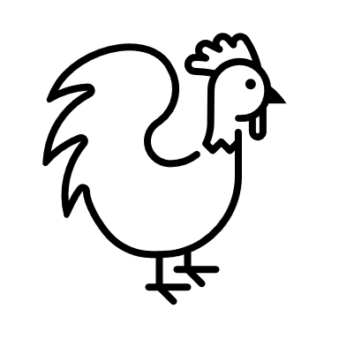  Petting Zoo | 11  Uno’s Tour $25.00   | 12
13  Week #5  this weeks field trips $49.00 | 14    AM: Museum Renwick Arts  PM: $12.00  Bowling | 15    Grocery Store Tour | 16  Splash park $5.00 | 17  Horseback Riding  $25.00 | 18  Field Day:  All sports & Relays | 19
20  Week #6  this weeks field trips $67.00 | 21  AM: Museum NASA  PM: Arts/Crafts  &Science | 22  Swimming  $10.00 | 23  Baseball MLB 25.00 Nationals   | 24  Women’s Basketball Game WNBA 25.00   | 25  Field Day:  Family Kickball Day!!! | 26

All field trips START at 9:00 AM SHARP. ANY/ALL Arrivals between 8:30am-9:00am WILL MISS BREAKFAST & BATHROOM USE! Please take care of this before late arrivals. NO ARRIVALS AFTER 9:00AM! We will return by 4:00PM. Early pick-ups MUST BE SCHEDULED and early dismissals will result in missed field tips. All Dates in Yellow are for 3yrs and up. Dates without color are for the 5yrs and up. Under 3yrs will have supervised activities at the facility. Payments are due FRIDAY BEFORE TRIP WEEK.
Summer Camp 2025
$7.00 gas weekly fee
MONTH of AUGUST total month cost- $179.00
Sunday | Monday | Tuesday | Wednesday | Thursday | Friday | Saturday
27  Week #7  $54.00  this weeks field trips | 28  AM: Jefferson Memorial  PM: Arts/Crafts  &Science | 29  Swimming  $10.00 | 30  Baseball MLB 25.00 Orioles | 31  AM: Library Story Time  Go Cart  $12.00 | 1  Field Day:    All sports & Relays  Cooking Class: Kid’s choice | 2
3  Week #8  $54.00  this weeks field trips | 4  AM: Museum  PM: Arts/Crafts  &Science | 5  AM: Library Story Time  Horseback Riding  $25.00 | 6  Swimming  $10.00 | 7  AM: Library Story Time  Movies:  $12.00 | 8  Field Day:  All sports & Relays  Cooking Class: Kid’s choice | 9
10  Week #9  $30.00  this weeks field trips | 11  AM: Lincoln Memorial  PM: Arts/Crafts  &Science |   12  Bank Tour  Dino Land | 13  Splash park  $8.00 | 14  Pump it up  $15.00 | 15  Field Day:  Family Kickball Day!!! | 16
17  Week #10  $41.00  this weeks field trips | 18  AM: Museum  PM: Arts/Crafts  &Science | 19  Bowling  $12.00 | 20  Swimming  $10.00 | 21  AM: Library Story Time  Go Cart  $12.00 | 22  Field Day:    All sports & Relays  New Student Orientation Day | 23
24 | 25  1st day of school!!!  NO AM CARE!!! |   26  Back | 27  To |   28  School | 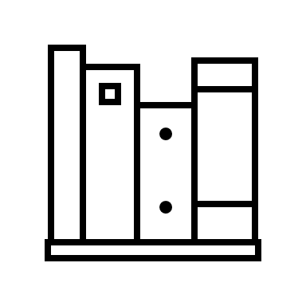  29 | 30
31 | 1 | 2 | 3 | 4 | 5 | 6

